Seizure Detection

Vineela Davuluri
dept. name of biomedical
(of Affiliation)
Vignan’s Foundation For Science, Technology & Research
(of Affiliation)
Vadlamudi, India
vineeladavuluri2@gmail.com
Prathiba Jonnala
dept. name of organization
(of Affiliation)
Vignan’s Foundation For Science, Technology & Research
(of Affiliation)
Vadlamudi, India
Madhav Raju Pamidi
dept. name of biomedical
(of Affiliation)
Vignan’s Foundation For Science, Technology & Research
(of Affiliation)
Vadlamudi, India
pamidimadhavraju4@gmail.com
Deekshita Sree Yarlagadda
line 2: dept. name of organization
(of Affiliation)
Vignan’s Foundation For Science, Technology & Research
(of Affiliation)
Vadlamudi, India
yarlagaddadeekshita8@gmail.com

Abstract— Over 50 million people worldwide suffer from epilepsy, a chronic neurological condition marked by erratic, recurrent seizures that have a major negative influence on patient safety and quality of life. Clinical electroencephalography (EEG) is still the gold standard for diagnosis, but it is not portable enough to be used for continuous, real-time monitoring at home. The recent developments in automated seizure detection, which move from conventional clinical setups to multi-modal Internet of Things (IoT) integrated systems, are thoroughly reviewed in this paper. We examine several detection techniques, such as Surface Electromyography (sEMG), Electrodermal Activity (EDA), and multi-criteria decision systems that use respiration and ECG. We suggest an integrated wearable framework that builds on these current technologies, combining a GPS module for real-time location tracking, a MAX30102 PPG sensor for heart rate and SpO2 monitoring, and a 3-axis accelerometer for fall detection. The suggested system offers a comprehensive approach to remote patient management and emergency response, and experimental results show high reliability in triggering alerts during falls and abnormal physiological changes.

Keywords—Seizure Detection, IoT, Emergency Alerts, Remote Monitoring

Introduction
Epilepsy is a long-term neurological condition that involves recurrent, unprovoked seizures caused by abnormal electrical activity in the brain. Epilepsy is one of the most prevalent neurological disorders affecting over 50 million people worldwide, as estimated by the World Health Organization (WHO). Types of seizures range from staring spells to the shaking depression, and you'll have everything from what looks like a 30-second daydream to the more severe and dangerous types, which can last for several minutes - your first instance probably leaves you feeling something a little closer to a wet dish cloth. Timely and accurate identification of seizure events is crucial for preventing injuries, minimizing emergency response durations and enhancing patient outcomes.

Historically, seizure monitoring depended heavily on the use of electroencephalography (EEG), a clinical approach that measures the brain’s electrical activity. Despite EEG being the gold standard for diagnosing seizures, its use is limited to a clinical/hospital environment, and therefore, continuous real-time seizure monitoring is challenging for the general population. This restriction has spurred the design of wearable seizure-detection devices, which promise portable and non-invasive monitoring in real-time.

In the case of state-of-the-art epilepsy seizure detection applications, biosensors like Accelerometers (to detect convulsive movement), Photoplethysmography(PPG) or ECG sensors (to measure heart rate and oxygen saturation), Electromyography (for muscle activity), Temperature and galvanic skin response (GSR) sensors (to analyse autonomic nervous system (ANS) signals) can be utilised in the system.

The growth of the Internet of Things (IoT) in medical monitoring has significantly enhanced the effectiveness of seizure detection systems. Thanks to cloud data storage, remote monitoring, and predictive insights, these innovations are paving the way for more personalized and flexible systems. This means we can step in earlier and move towards a broader vision of telemedicine and digital health.

Seizures are sudden and unpredictable events that can have serious consequences that may not be managed promptly. For individuals living with conditions like epilepsy, the constant fear of having a seizure, especially when alone, can significantly affect their daily lives. In many cases, timely assistance during or immediately after a seizure can make a major difference in safety and recovery. However, without continuous monitoring or someone nearby to help, getting that support isn't always possible.

These challenges inspired the development of our seizure detection system for a combination of real-time health monitoring and instant alert communication. The heart of the system is an ECG (electrocardiogram) sensor, which tracks the user’s heart activity. Since many seizures are accompanied by changes in heart rate or rhythm, by that we are analyzing ECG signals, which provide a reliable way to detect possible seizure events by the ECG(electrocardiogram) sensor.

The system is designed by lightweight, user-friendly, and practical for daily use. The app wasn't only for alerts and other conditions during a suspected seizure but also stores ECG data of parameters like (Heartbeat,Spo2,Temperature),Fall Detection, emergency alert system for later review, which can help doctors for better understanding of the user’s condition over time. By combining low-cost wearable technology with mobile app functionality, this project aims to offer a real-world solution for a very real world problem.

In this paper, we are aiming to present a system that predicts seizures for epileptic patients by monitoring the heart rate, SpO2, temperature, as well as the patient's movements. This paper is a part of a complete project aiming to implement and test the whole system. Thus, a state-of-the-art, as well as a prototype of the proposed system with measured and simulated results, will be presented.

Literature survey
From clinical, non-portable EEG-based systems to adaptable, wearable, and Internet of Things-integrated solutions, the field of automated seizure detection has developed. The different approaches and tools created to improve patient safety and objective monitoring are examined in this survey.
A. Clinical Evaluation and Device Performance
Methodical Evaluation: A thorough analysis reveals that although 20–30% of patients have refractory epilepsy, no single device can currently identify every kind of seizure. Seizure semiology has a major impact on effectiveness, highlighting the need for multi-modal or customised detectionsystems[1].
Objective Monitoring: Automated systems are essential for giving an objective evaluation of seizure frequency, which patients frequently report inaccurately. This enables more individualised treatments[1].

B. Detection Based on Physiological Signals
Researchers have investigated various physiological markers beyond traditional EEG to enable portable monitoring:
Electrodermal Activity (EDA): Research has demonstrated that epileptic seizures, especially generalised tonic-clonic seizures (GTCS), cause a massive sympathetic discharge. Wearable sensors can measure this surge in EDA[1,6].
Surface Electromyography (sEMG): sEMG has become a dependable non-invasive technique for identifying motor seizures. Experimental systems have utilized wireless sEMG recording devices to detect seizures with a low false detection rate of 0.003/h[1,8].
Versatile sEMG Systems: More recent sEMG systems have a compact, wireless, and power-efficient architecture that allows them to be worn on different body parts without being affected by movement artefacts. These systems are intended for long-term monitoring[1,7].

C. IoT-Integrated and Multi-Modal Systems
The accuracy of detection and response times have been greatly enhanced by the integration of multiple sensors and IoT technology:
Multi-Criteria Decision Systems (MCDS): Researchers have created low-cost wearables that employ LSTM-based anomaly detection algorithms to achieve high precision (96%) and recall (90%) in real-time by combining parameters like ECG, EDA, body motion, and breathing rate[1,2].
Edge Computing in Seizure Detection: Hardware implementations now use edge computing to process EEG signals in real time. For example, systems on a Raspberry Pi that use EEMD-based classification can attain an accuracy of 88.6%[1,4].

Specialised IoT Applications: IoT modules that integrate EEG and alcohol (MQ3) sensors to monitor drivers and regulate vehicle engines during a seizure event have been created especially for vehicle safety[1,3].
Portable Assistance: Innovative portable systems concentrate on EMG-based assistance to alert nursing staff and carers, possibly averting injury or death through prompt notifications

Related Work

By combining a wide range of sensors—such as an accelerometer for fall detection, a PPG sensor (MAX30102) for vitals, and a temperature sensor—into a single IoT framework, our research paper advances these ideas. Our system addresses the need for a multifunctional device that combines vital sign monitoring, physical safety (fall detection), manual intervention (panic button), and real-time GPS location tracking for emergency response, in contrast to previous works that frequently concentrate on a single modality like sEMG or EDA.

Design & Implementation Of Seizure Detection System
The complete block diagram of the proposed system is illustrated in Fig. 1. It is made of a wearable health and hazard detection device made with an Arduino Uno microcontroller. It combines several sensors and modules for online monitoring and emergency warning.
The MH-ET LIVE MAX30102 module is used to obtain physiological signals such as heart rate and SpO₂ data. An in-built accelerometer can tell when motion or irregular movements such as a fall take place. These are read in, processed by the device, and shown on a 16×2 LCD to display the current status — says “FALL & PUSH".
There's also an emergency manual alert push button with this system. Two buzzers are built into give audible alerts if the person falls over or is in need of assistance. Moreover, there is a GPS module which keep a continual record of the user's location that can be very vital in case of any drop or health emergency.
The data are transmitted to a mobile application based on IoT with the help of a Wi-Fi module. Real-time app monitoring lets you see heart rate, oxygen saturation, temperature, push-button activation, and GPS location and call for emergency help at the touch of a button.
Programming of the Arduino Uno is done through USB and the computer interface, and it performs data acquisition, decision making, and communication. It provides a more cost-effective solution for complete real-time health monitoring and alerting people in need: elderly and high-risk individuals.
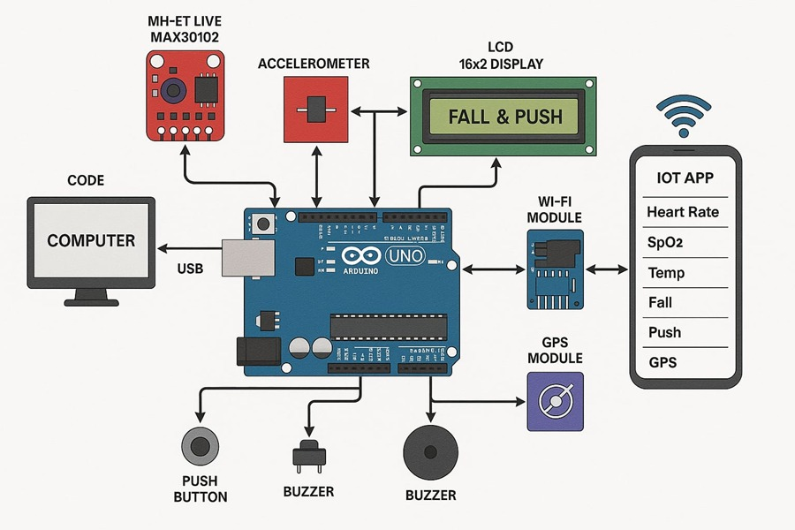
Fig:1 Block Diagram of the Proposed System
The system communicates wirelessly using a Wi-Fi module to send sensor data to an IoT application on a mobile. This application displays multiple parameters:
Heart Rate
Spo2
Temperature (If optional Sensor is installed)
Fall status
Push-Button Alert
GPS Location
In this configuration, the patient and caregivers can receive real-time monitoring and alerts. The system is operated by a wire from a computer through a USB connection, where an Arduino code is uploaded to perform signal processing, generate an alert, and control communication.
A. Monitoring of Heart Rate & SpO₂ (MAX30102 Module)

Recording of the heart rate, saturation level of oxygen (SpO2) and temperature is important for assessing the cardiovascular and respiratory condition of a patient. The system utilises the MH-ET Live MAX30102 sensor, a compact reflective photoplethysmography (PPG) module designed for wearable applications.

The Max30102 consists of two light-emitting diodes(LEDs) - a red LED (660nm) and an infrared LED (880nm), along with a photodetector that measures the variations in light absorption through the skin. These variations correspond to changes in the blood flow volume, from which the heart rate and SpO2 Levels are derived.

The sensor is typically positioned on the wrist near the radial artery, allowing continuous, non-invasive monitoring of Physiological signals. The Digitised sensor data is transmitted to an Arduino Uno, which periodically processes the data and calculates the threshold conditions to identify anomalies.

In the case of abnormal values for heart rate (HR 100 bpm) or SpO₂ (SPO₂ < 90%), an alert algorithm is triggered automatically by the system.E.g.: it can display a warning on the LCD screen, sound an alarm with the buzzer, and transmit the patient vitals and the GPS coordinates to the caregiver’s mobile application through the Wi-Fi module. This kind of early discovery is important for situations such as cardiac arrhythmias, respiratory failure, or seizure-induced autonomic dysfunctions, in which the detection and response may save from fatal diseases.

Combining this sensor with a wearable device enables continuous and real-time monitoring of vital signs for elderly people or patients with long-term neurological or cardiovascular disease.
B. Fall Detection (Accelerometer)
In particular, fall detection is an important consideration in the present system for patients who may be susceptible to rapid physical decline (elderly patients, epileptics). This device includes a 3D accelerometer that tracks the user's motion in three- dimensional space (X, Y, and Z axes).
Normally, this length of the vector lies within a physiological range. But in case of a fall, the accelerometer records an abrupt and steep acceleration change and then a short period of immobility, which can be considered as the impact and being fallen over, respectively. SignalAce is able to recognize these moving patterns by employing threshold-filter algorithms and time- window analysis. If calculated VM exceeds a predefined threshold for fall (e.g., >2g) and there isn't beneficial movement for some time after, then fall is confirmed.
When a fall is detected, the platform triggers a multilevel warning process. 3.1 Fall & Push: The visual indication on the LCD module is illuminating textual content saying “FALL & PUSH” with a warning sound representing the vibration to alert nearby people. At the same time, the Arduino uses the Wi-Fi module to send a fall status and real-time GPS location to the linked IoT mobile app. In that way, the kit's "human alert" mechanism makes sure that those caring for the gear, or emergency services personnel, can act fast.
The accelerometer is positioned in the wrist-worn part of the wearable, where it can take advantage of the swift actions of one’s limbs. The system runs at the sampling rate of 100 Hz, which is more than the Nyquist rate for human motion, which makes for accurate and robust fall detection.
C. Push Button Interface
The system presents a push button as a specific manual emergency trigger, to alert and communicate to a caregiver intuitively and immediately in case of distress or if a user feels an approaching health crisis, such as a seizure aura, giddiness, and difficulty in breathing. Unlike sensors and threshold-based automatic detection systems, the push button allows the user to proactively set off an alarm, simply because he/she feel they need immediate help - something that may occur even before body data or motion data indicate a critical situation.
This module is connected to the digital input pin of the Arduino Uno directly, and is observed constantly, either interrupt-driven or with a polling mechanism. Once the button is pressed, the Arduino detects that as a HIGH signal transition, and the alert process will be started. This includes:
Setting off an audio buzzer alarm to alert those in the nearby areas.
SHOWING A MESSAGE (e.g., “EMERGENCY” or “HELP NEEDED”) ON THE LCD DISPLAY.
Transmitting a real-time alert while containing the GPS data, heart rate data, and SpO₂ data of the user to the caregiver application on the IoT system via the Wi-Fi module.
The pushbutton interface is a fail-safe resource, which is crucial in cases where the patient is still conscious, and can also pick up warning signs before the automated system does. It makes the system responsive and increases personal expertise and reliability in safety-critical situations.
D. GPS Location Tracking
For emergency health-care monitoring systems, the location awareness is of significance to realize the time of intervention. Calling for GPS Module advanced geolocate in real time. The device processes satellite signals that it receives in order to determine the latitude, longitude, and optionally, the altitude and time when the patient is in a desirable location.
The Arduino Uno continuously or periodically reads this geospatial information and stores it in temporary memory buffers. When an incident is recognised – whether a fall, or an abnormal physiological reading is detected – or an alert is triggered with a push of a manual push-button, the most recent GPS position is paired with the health data and sent via the Wi-Fi module to the caregiver or monitoring centre.
This feature is particularly important in the case of ambulatory patients, for example, elderly patients living alone or patients with a history of seizures who would be walking or falling in a public space. With the ability to get the precise location of a patient, caregivers can quickly provide assistance or arrange for emergency medical care, there by reducing response time and possibly saving lives.
In addition, the incorporation of a GPS allows for location-based analytics – to identify high-risk / hotspots zones or recurring incident locations that will facilitate intelligent, preventative visiting and home-care planning in the future.
E. Wireless Communication (Wi-Fi Module)
The Wi-Fi communication module, which allows for seamless data communication between the wearable device and its IoT mobile application, is the basis for the ability to monitor remotely in this system. The module can connect to a local Wi-Fi network and also send data to AWS IoT Core using the TCP/IP or MQTT standard protocols. By connecting the Wi-Fi module, the Arduino Uno can send all health-related data (heart rate, SpO₂ levels, fall detection, GPS location, and even button alerts) to a cloud-based IoT platform or a smartphone application in real-time. This cloud-based integration enables caregivers and doctors to gain access to patient data almost anywhere through mobile and web interfaces. This wireless setup thus cuts down the number of physical connections and data-logging devices, and it additionally supports the monitoring of several patients at a time. Data encryption, access authentication, and security cloud APIs are among the security measures taken to protect medical sensitive data's confidentiality and integrity. Moreover, if the network is lost, the Arduino can be programmed to save the sensor readings on its memory and then send the readings when the network is back, thus ensuring continuous monitoring. Wireless communication, therefore, completes the closed-loop to finally achieve uninterrupted, remote, and dynamic health monitoring which is especially crucial in chronic and neural disorders requiring constant monitoring.

Software
We also created a software simulation of the wearable seizure detection system using Proteus to test before prototyping the embedded systems. The quality of the core components of the system is confirmed by the simulations: the heart rate and SpO2, accelerometer fall detection, and vibrating alert activation.

Heart Rate and SpO₂ Monitoring Module

The simulation shows a heartbeat sensor (HB1) connected to Arduino Uno and a 16x2 LCD for the inconvenience of real-time display of heart rate (beats/min) and oxygen saturation (SpO₂%) to be displayed. Every pulse from the heartbeat sensor is transformed into an analog signal and displayed on the Arduino's analog input. The mechanism counts pulses in ten seconds using a counter-based timing that determines the heart rate according to the equation: The simulated SpO₂ can be shown on the LCD along with the time elapsed and heart rate in real-time counting. If the pulse rate goes beyond abnormal limits, a buzzer (BUZ1) sounds to alert the caregivers.

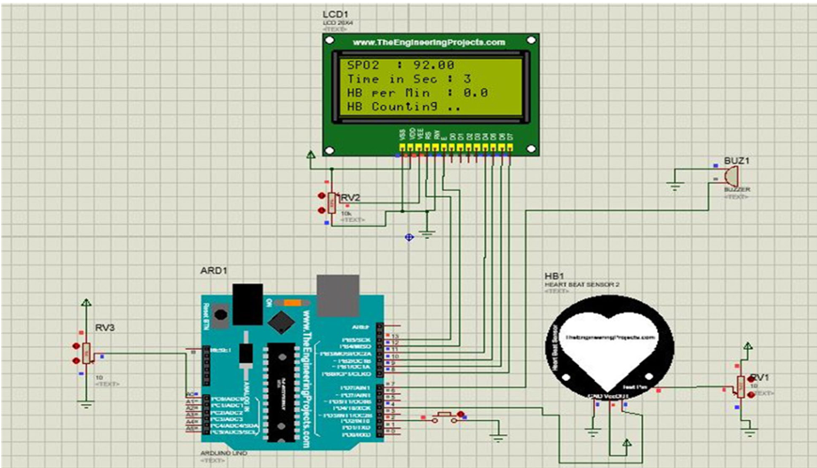
Fig : 2 Heart Rate & SpO2

Accelerometer-Based Fall Detection Module

This simulation is meant to test the proper interfacing of the sensor with the microcontroller and proper data handling and display logic. Fall-ADXL335-3axis-with-ADXL335-on-Arduino This module simulates the working of an ADXL335 3-axis accelerometer on an Arduino Uno board and uses the output to detect a fall. The sensor provides the X, Y, and Z axes' continuous analog information, and as a result, only some analog pins are required for cross-axis values. These values appear on an LCD, where they are updated in real-time.

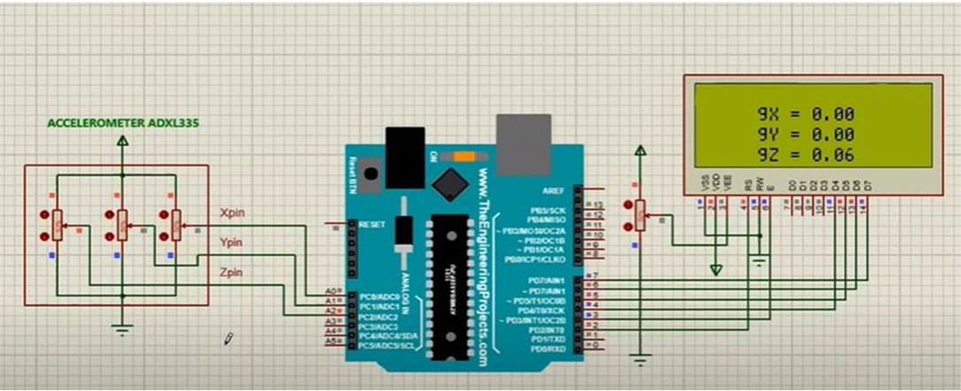
Fig : 3 Accelerometeer

Vibration Alert and Emergency Detection Module

A fall is detected if the calculated acceleration surpasses a designated limit and a specific period of stillness has transpired. This research aids in adjusting the sensitivity and authenticating the algorithm for minimising false positives and false negatives in dynamic conditions. This module presents an emergency vibrating-alert function.

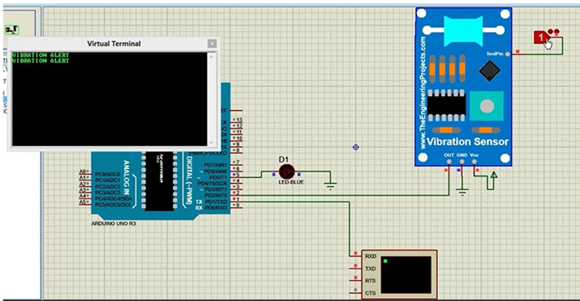
Fig : 4 Emergenecy Alert

Flow Chart & Algorithm

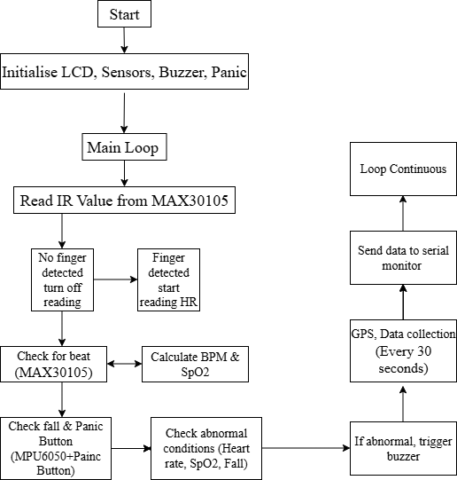

Fig : 5 Flow Chart of Proposed System

The flow chart illustrates a working principle of seizure detection by a wearable system. We begin by setting up all components: LCD display, sensors (heart rate and SpO₂ with MAX30105), buzzer, panic button. The software then repeatedly monitors the IR sensor to see if a finger has been placed. If a finger is detected, it starts measuring the heart rate and blood oxygen levels. It also looks for falls with the MPU6050 sensor and if the panic button is clicked. It measures the heart rate and SpO₂ level, and if the system detects any abnormal signs — for instance, low SpO₂, an irregular heartbeat, or if a person falls down — it sets the buzzer to go off as an alarm. Also, after 30 seconds, the GPS gets the data, all the sensor reads and sent to the serial monitor for tracking / remotely viewing. This process repeats to monitor health constantly and quickly, in the event of an emergency.

Algorithm:
The seizure detection apparatus implements a predefined protocol to monitor physiological data, detect occurrences of a deleterious event (e.g., seizure or fall), and send an alert to a caregiver in response thereto. The system is intended to be a self-contained, persistent, and standalone one, which consists of a wide range of biosensors combined with microcontroller logic and wireless communication.
Step 1: System Initialisation
After the Arduino Uno microcontroller is turned on, everything gets initialised:
The (16x2) LCD screen lights up to offer instantaneous visual feedback of the system state.
The MAX30105 sensor is set to read heart rate and SpO₂, using red and infrared light.
The MPU6050 accelerometer is used to perceive a fall-like motion.
The panic button input is adapted to detect manual alerts issued by a user. The buzzer is activated for acoustic alerts in an emergency.
The GPS module is powered up to receive geo-location information.
This preparation stage prepares all the modules for real-time data readout and processing.

Step 2: Main Loop Execution
Upon initialization, the system enters a running main loop which constitutes the essence of real-time monitoring. It is inside this loop that the system reads sensor data and processes the user health and activity in both a pipelined and parallel manner.
Step 3: IR Signal Acquisition and Finger Detection
The microcontroller first reads the IR value from the MAX30105 sensor to real- ize that the user's finger is correctly placed. This check avoids unnecessary sensor data processing, when the sensor is not in contact with the skin.
If no finger is sensed, the sensor is powered down to save power.
Once a finger is identified, the system starts to acquire the IR waveform data to calculate the BPM and the SpO₂ with the PPG algorithms.
Step 4: Heartbeat and SpO₂ Calculation
The system processes the incoming waveform data:
Heart rate ( BPM ) is calculated by counting the peak values of the IR signal over an agreed-upon time window.
SpO2 is calculated based on the ratio of red/infrared light absorption by blood.
These calculated values are temporarily stored and displayed on the LCD display.
Step 5: Fall Detection and Panic Button Monitoring
At the same time, the system reads the motion data recorded by the MPU6050 accelerometer. By looking at sudden spikes in acceleration or unusual orientation changes, it will determine if a fall has occurred.
The fall detection logic uses thresholds and timing to differentiate between normal motion and a dangerous fall.
As well the panic button is polled at each loop iteration. If someone presses the panic button, it's to indicate that they're experiencing discomfort, an aura or that they are afraid to have a seizure.
Step 6: Abnormality Detection
All acquired data is compared against pre-programmed thresholds to detect abnormal physiological/physical conditions:
Heart Rate: Abnormal if 60 bpm (bradycardia) or >100 bpm (tachycardia)
SpO₂: Abnormal if <90% (hypoxemia)
Fall: Detected by motion pattern
Panic: Manual trigger by user
If any of those abnormalities are detected, the system is ready to issue an alert.
Step 7: Alert Generation
When an emergency is confirmed:
The buzzer will then go off and make a loud screech, which can alert people nearby.
The LCD will flash with a message describing the abnormality (e. g. “LOW SpO2”, “FALL DETECTED”).
This alert state ensures immediate attention to the user’s condition.
Step 8: GPS Data Collection
At pre-defined intervals (every 30 seconds) the system recieves the GPS data from the GPS module. The geolocation (latitude and longitude ) accuracy is critical for locating the patient in case of an emergency.
This location information is synchronised with the health status and stored
/transmitted remotely.
Step 9: Data Transmission to Remote Monitor
All collected/processed parameters (cardiac rate, SpO2, fall detection status, panic signal, GPS coordinates) are sent to the serial monitor or an IoT app connected to the cloud by means of the Wi-Fi module.
This enables caretakers/ family members / medical personnel have active monitoring in real-time of the patient's condition.
Step 10: Loop Continuation
Then the system goes back to the beginning of the loop and continues monitoring the patient normally. In this looped configuration, the system has constant real-time, uninterrupted monitoring of vital signs and patient activity so that it may be detected and assisted in time in case of events of seizure or progression of the condition of the patient.
This algorithm is the core of the seizure detection system, which combines biosensor data, motion sensing, user interaction, alerting mechanisms and remote communication into one cohesive and responsive health-monitoring platform. The structured and continuous loop design provides high reliability and real-time performance required for chronic neurological disorders such as epilepsy.

Results & Discussion
We have developed and tested a system for seizure detection integrating multiple biosensors with IoT capabilities for real-time monitoring of patients with cardiac infarction. The device comprises: - heart rate and SpO2 sensor - temperature sensor - accelerometer used to detect fall - GPS module, push button trigger, and LCD display interfaced with Arduino Uno and ESP8266 Wi-Fi module. Data collected is uploaded to a custom IoT mobile application for remote visualisation.

Hardware Results
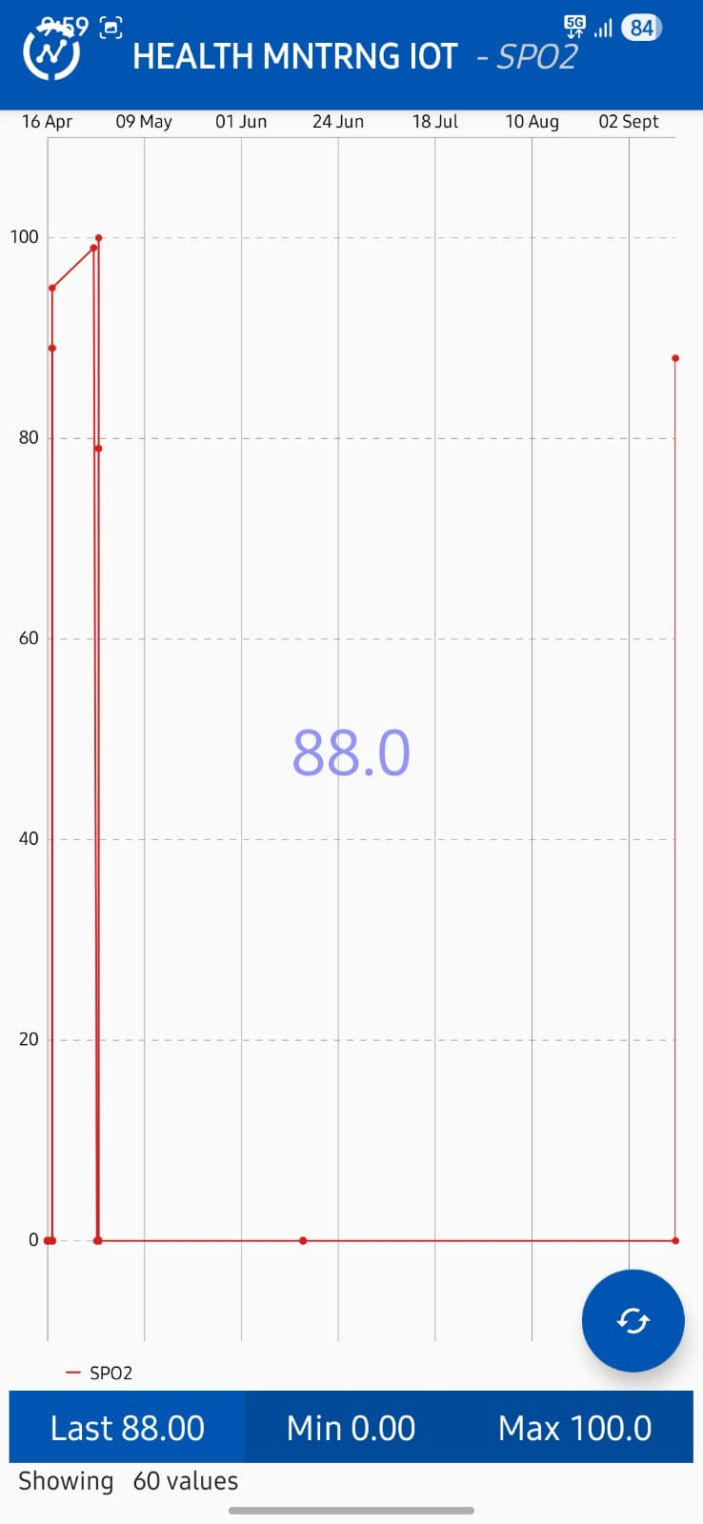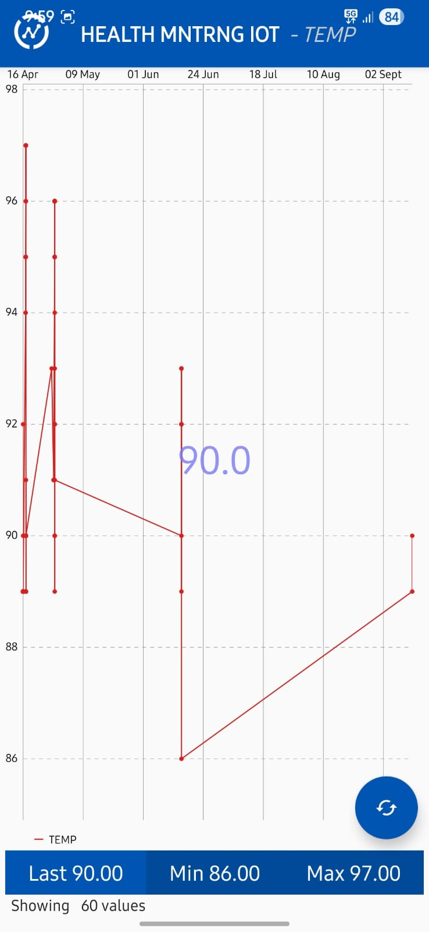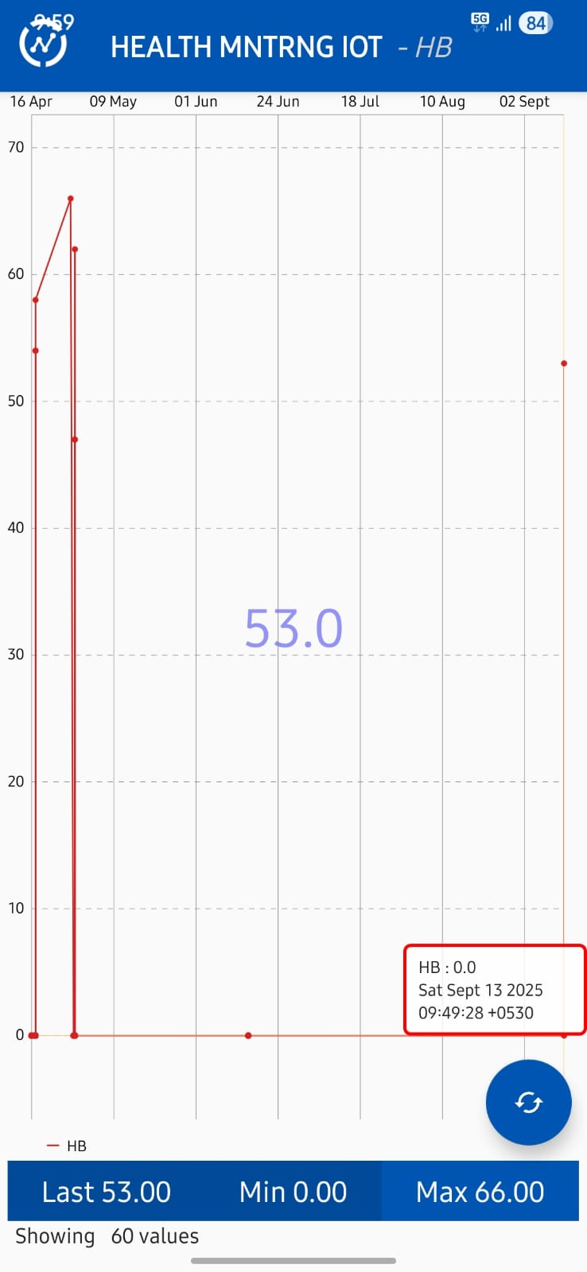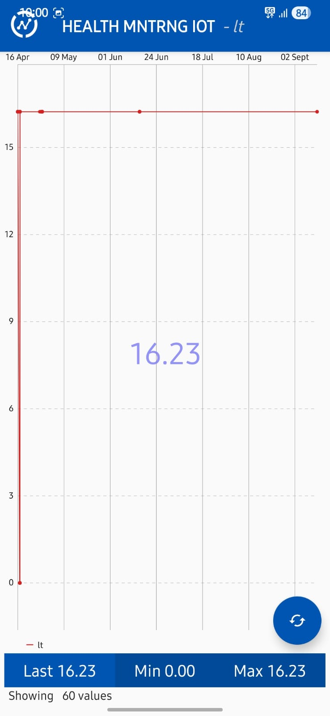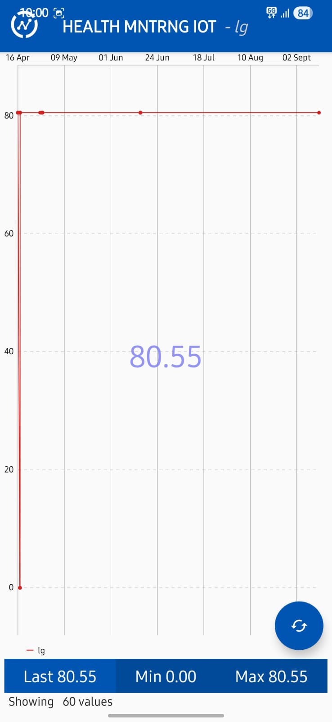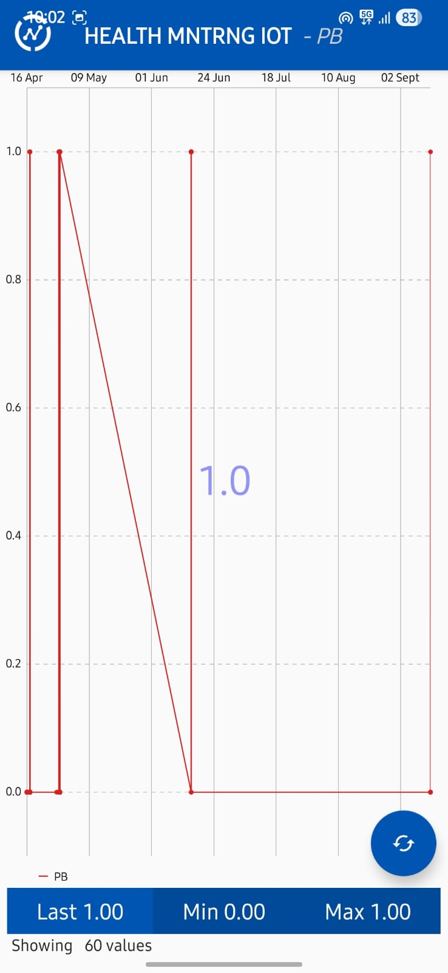

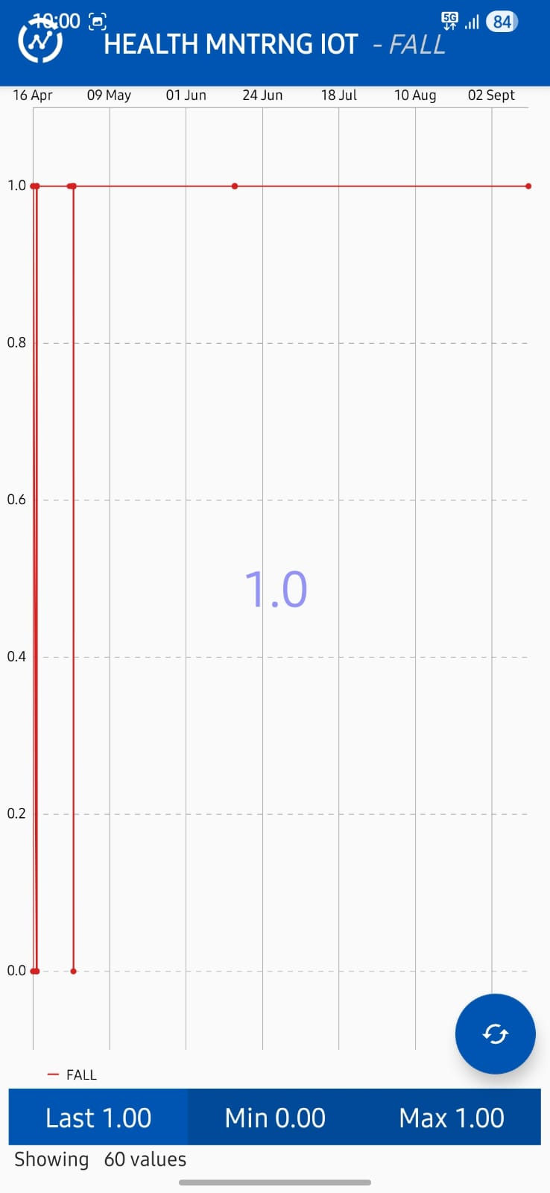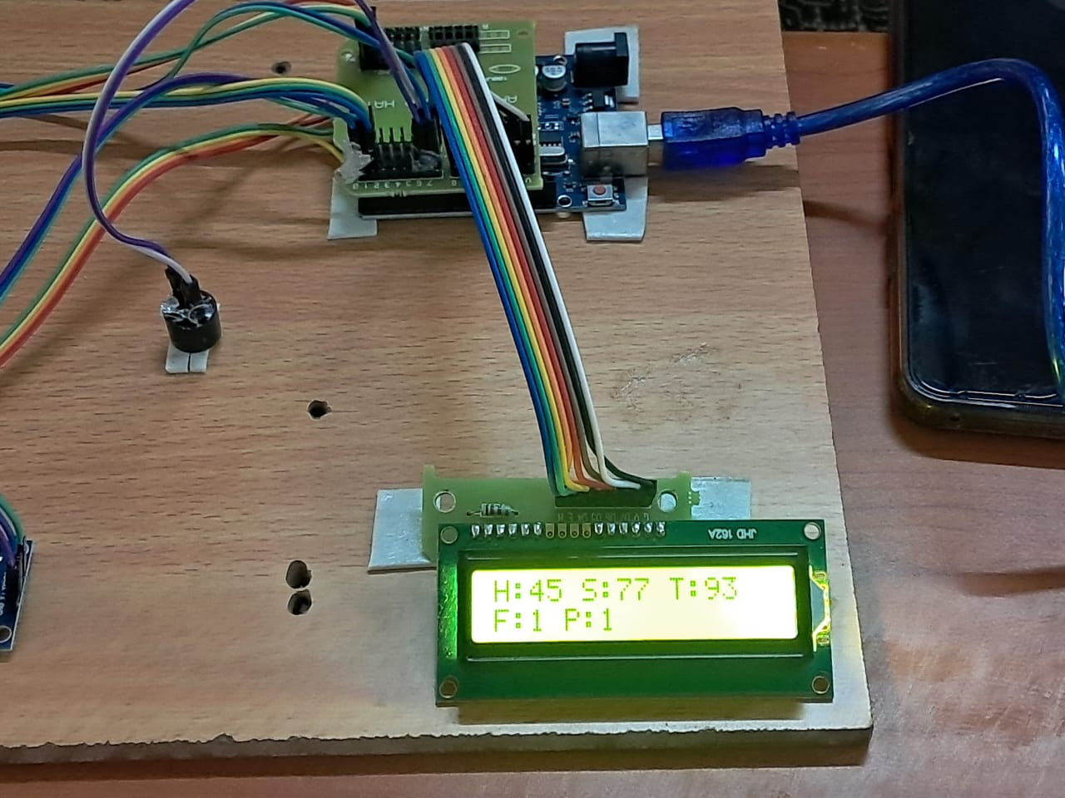

Hardware Results

Table 1: Results

Parameter | X-Axis | Y-Axis | Unit | Threshold Range | Result
SPO2 | Time | Oxygen Saturation | % | >95% | 88.00
Heart Beat | Time | Heart Rate | bpm | 60-100 bpm | 53.00
Temperature | Time | Body Temperature | Fahrenheit | 97-99 | 90.00
Fall | Time | Fall Trigger | Binary | 0 or 1 | 1.00
Push Button | Time | Panic Button | Binary | 0 or 1 | 1.00
Longitude | Time | Longitude | Deg | N/A | 80.55
Latitude | Time | Latitude | Deg | N/A | 16.23

B. System Responsiveness and Accuracy
The system effectively triggered alerts based on:
Sudden fall detection via accelerometer signals.
Abnormal vital signs such as reduced heart rate or SpO2.
Manual activation through the push button.
The GPS module consistently returned patient location information which was transmitted to the cloud for remote monitoring (this information was not displayed on the LCD).
C. Discussion
The results suggest the feasibility of an IoT-based wearable health monitoring and seizure alert system for epileptic patients, a binary detection system of fall and manual alert easily identifies important events, and physiological parameters help to intervene in time.
Compared to the current system that combined the data of multiple sensors, the new system was able to detect seizures (e. g. suddenly falling, abnormal heart rate, or oxygen depletion), along with other emergency situations (i.e. caregivers' real-time visualization).
Limitations may be sensor noise and/or false positives (fall detection can be one example). Future enhancements could include EEG sensors to detect seizures more accurately, machine learning algorithms that reduce false alarms, and improve prediction accuracy.

Conclusion

Automated seizure detection systems need to be developed to reduce the risks of physical harm and Sudden Unexpected Death in Epilepsy. Research shows that using multiple sensing methods greatly increases detection accuracy while lowering false alarm rates by combining physiological, motor, and autonomic signals. This work effectively combined the latest in wearable detection technology and presented a functional IoT-based design to meet the urgent need for continuous, non-invasive monitoring. Our prototype showed good responsiveness to unexpected falls and abnormal vital signs through cloud integration and GPS tracking, ensuring timely alerts to caregivers. Although the current results are promising, future research should focus on integrating edge-computing algorithms and lightweight EEG sensors to further improve the clinical usefulness and predictive accuracy of the wearable device.

References
- Ulate-Campos, A., et al. "Automated seizure detection systems and their effectiveness for each type of seizure." Seizure 40 (2016): 88-101.
- Ahmed, Abdullah, et al. "A wearable sensor based multi-criteria-decision-system for real-time seizure detection." 2017 39th Annual International Conference of the IEEE Engineering in Medicine and Biology Society (EMBC). IEEE, 2017.
- Jagtap, Sushma S., et al. "GPS based IoT Module for Vehicle Safety in Epileptic Seizure Detection and Alcohol Monitoring." 2024 4th International Conference on Pervasive Computing and Social Networking (ICPCSN). IEEE, 2024.
- Torse, Dattaprasad A., et al. "Hardware implementation of automated seizure detection system using EEG signals and edge computing." 2022 6th International Conference on Trends in Electronics and Informatics (ICOEI). IEEE, 2022.
- Bagavathi, C., et al. "Novel epileptic detection system using portable EMG-based assistance." 2022 International Conference on Applied Artificial Intelligence and Computing (ICAAIC). IEEE, 2022.
- Poh, Ming-Zher, et al. "Continuous monitoring of electrodermal activity during epileptic seizures using a wearable sensor." 2010 annual international conference of the IEEE engineering in medicine and biology. IEEE, 2010.
- Das, P. Sarati, et al. "A versatile wearable sEMG recording system for long-term epileptic seizure monitoring." 2021 43rd Annual International Conference of the IEEE Engineering in Medicine & Biology Society (EMBC). IEEE, 2021.
- Conradsen, Isa, et al. "Evaluation of novel algorithm embedded in a wearable sEMG device for seizure detection." 2012 Annual International Conference of the IEEE Engineering in Medicine and Biology Society. IEEE, 2012.

.

